Test Case: Login → Team PageVerification
Week 4 – Team 38, AI Digital Marketing (Team B)
Project | Team 38 – AI Digital Marketing (Team B)
Status | Complete
Tester | Minh Vu

Preconditions
- The feature has been deployed to a live/staging URL that is reachable without a local dev environment.
- A valid, registered test account (email + password) exists and is known to the tester.

Test Data
- URL: https://ai-digital-marketing-team-b-fronten.vercel.app/
- Test account email: Cuong20040607@gmail.com
- Test account password: TestPassword123_
- Expected team page content: Each Individual profile, with their role and short description

Test Steps
Step | Action | Expected Result
1 | Open a browser and go to the deployed application URL | The application loads successfully and the Login page is displayed with no errors.
2 | On the Login page, enter a valid, registered email address in the Email field. | The email is accepted in the field with no validation error shown.
3 | Enter the correct password for that account in the Password field, then click "Login" / "Sign in". | The credentials are accepted; no error message appears; the page begins navigating away from Login.
4 | Observe the URL and page after login completes. | User is automatically redirected to the Team page (correct URL/route for the logged-in user's team).
5 | Review every section of the Team page against the requirements/spec for this feature (e.g. team name, project title "AI Digital Marketing", team members list, AI-generated content, or other required fields). | All required content is present, accurate, and complete with no missing fields
6 | Check page rendering: images/avatars load, layout is not broken, and no visual errors appear (desktop viewport). | Page renders cleanly with correct formatting and no broken elements.

- Open a browser and go to the deployed application URL
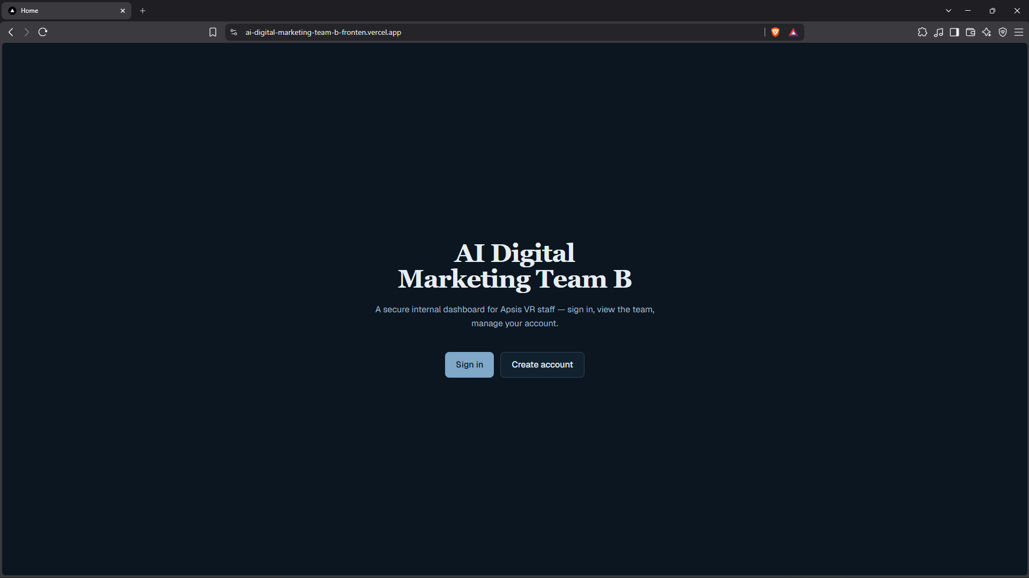

- On the Login page, enter a valid, registered email address in the Email field.

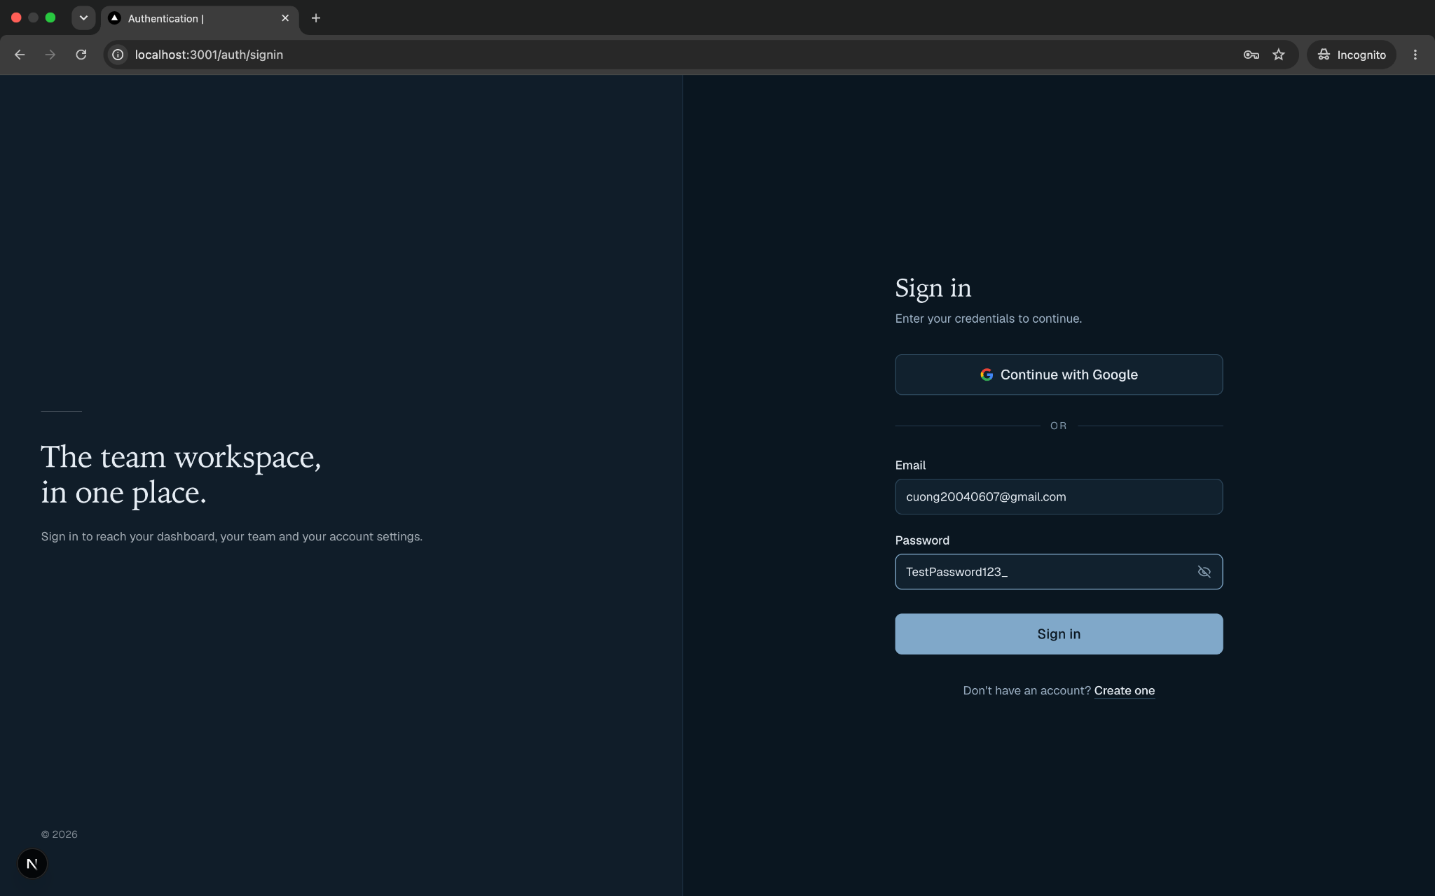

3.Enter the correct password for that account in the Password field, then click "Login" / "Sign in"

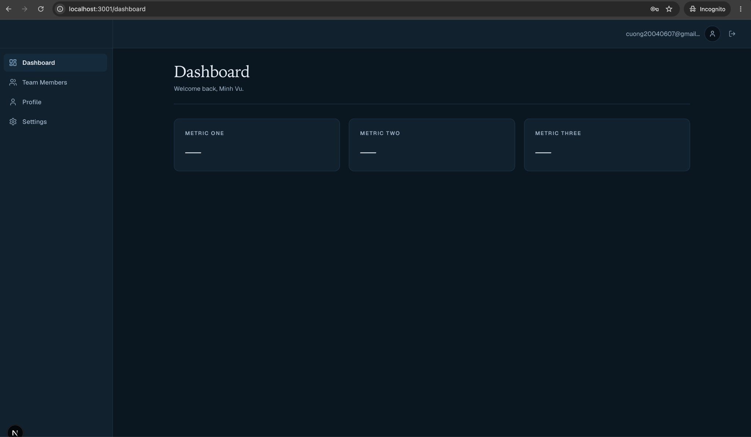
4.Observe the URL and page after login completes.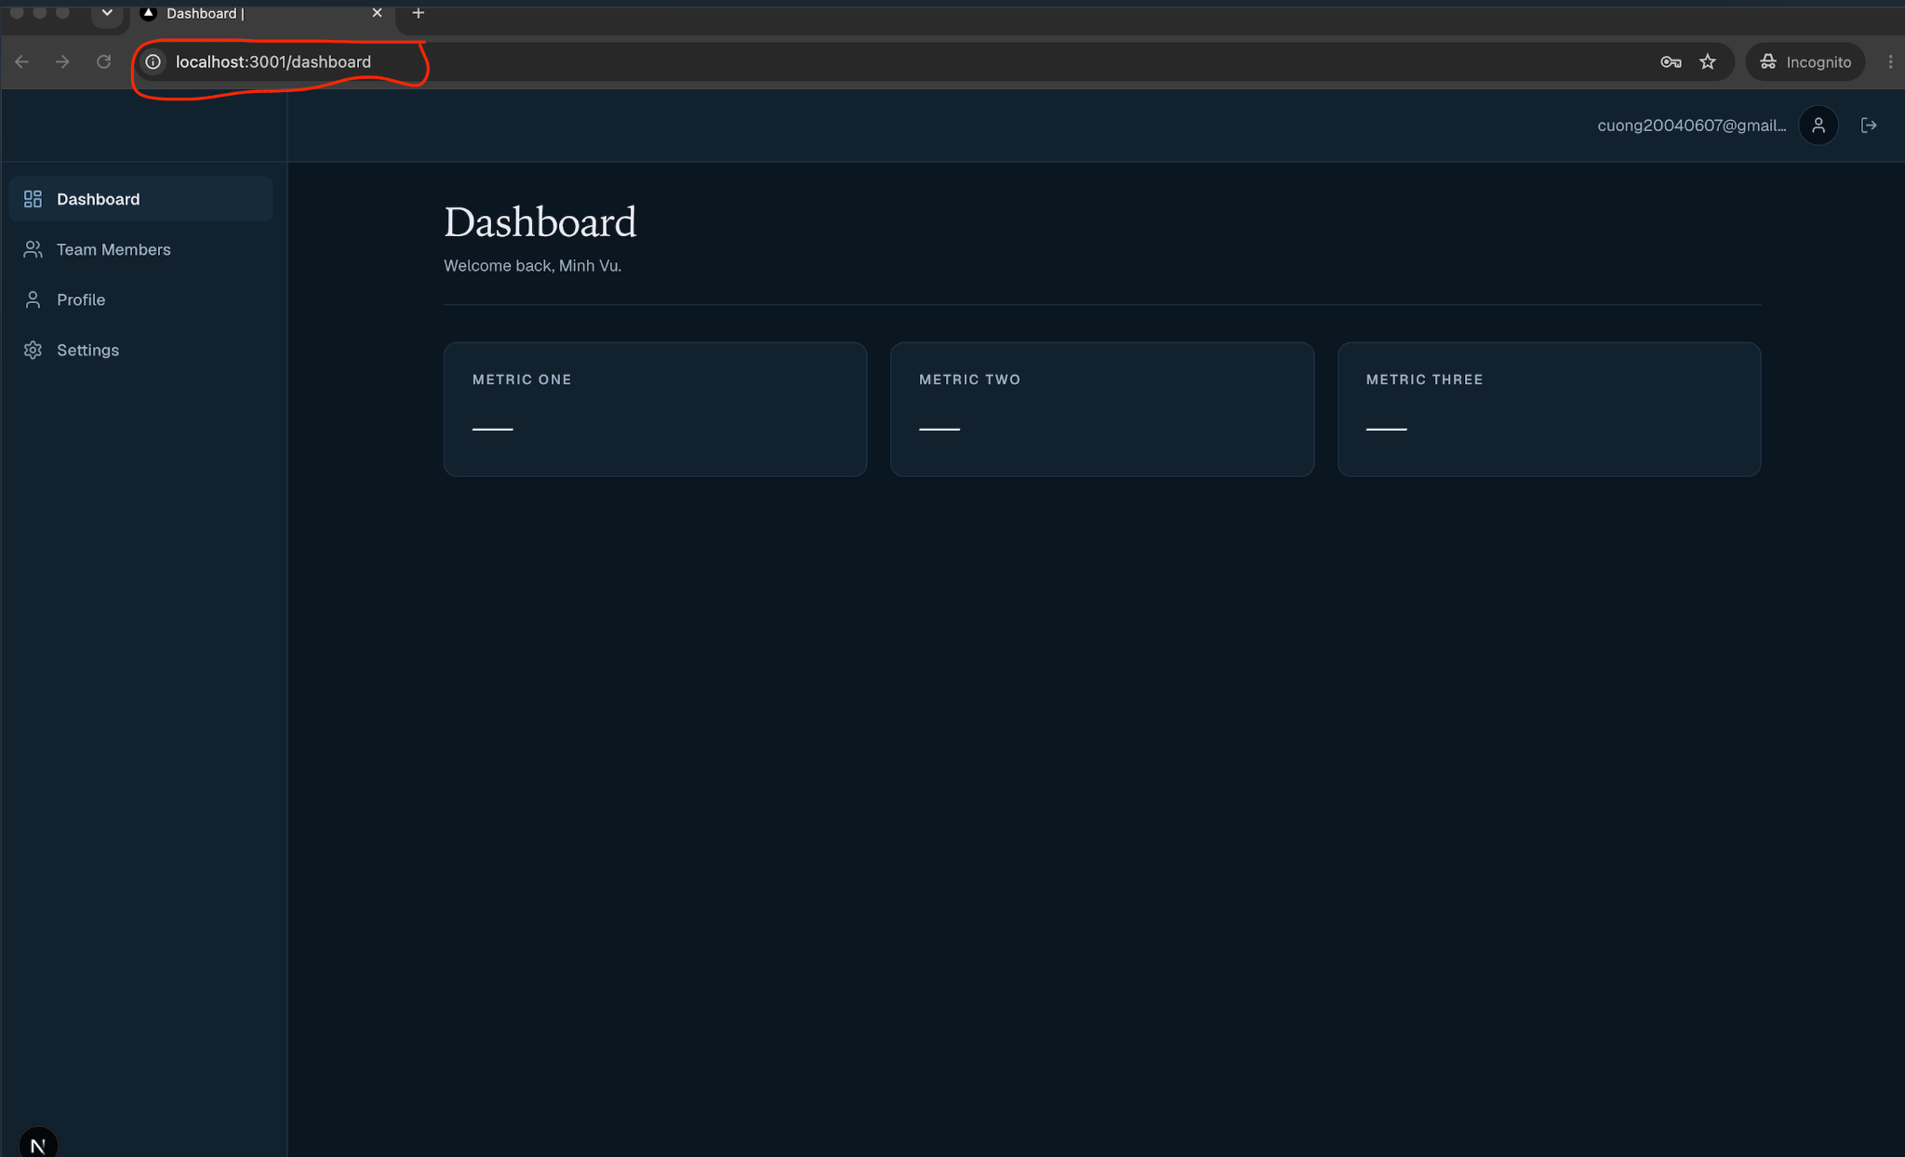

5. Review every section of the Team page against the requirements/spec for this feature (e.g. team name, project title "AI Digital Marketing", team members list, AI-generated content, or other required fields).
&
6. Check page rendering: images/avatars load, layout is not broken, and no visual errors appear (desktop viewport).
